# Phase-3 Student Name: GANGA DEVI .S

Register Number: 420723106020

Institution: [CK.College of engineering and technology]

Department: B .E ECE

Date of Submission: [13/05/25]

# Github Repository

# <https://github.com/Gangasundar234/Recognizing-Handwritten-Digits-with-Deep-Learning-for-Smarter-AI-Application>

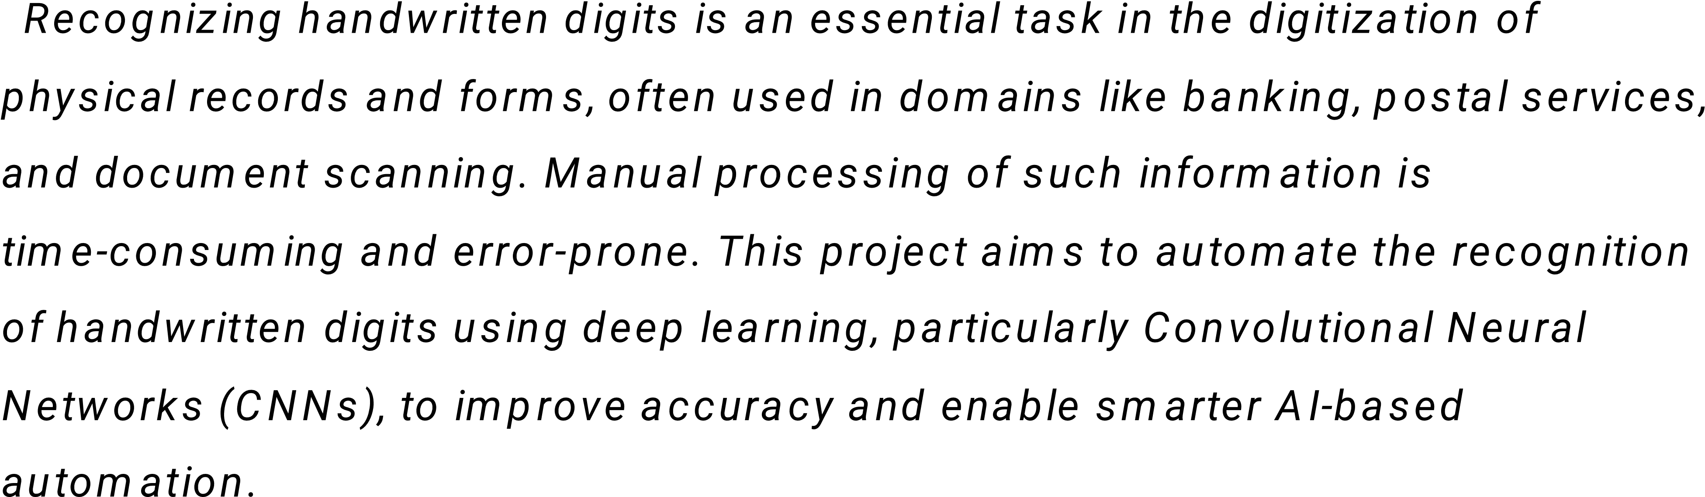

## 2. Abstract

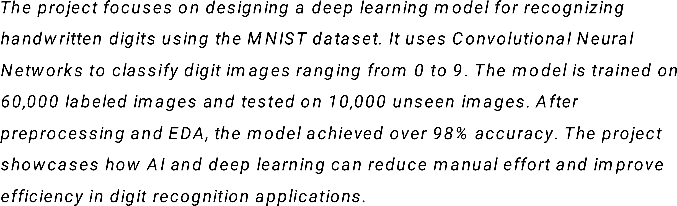

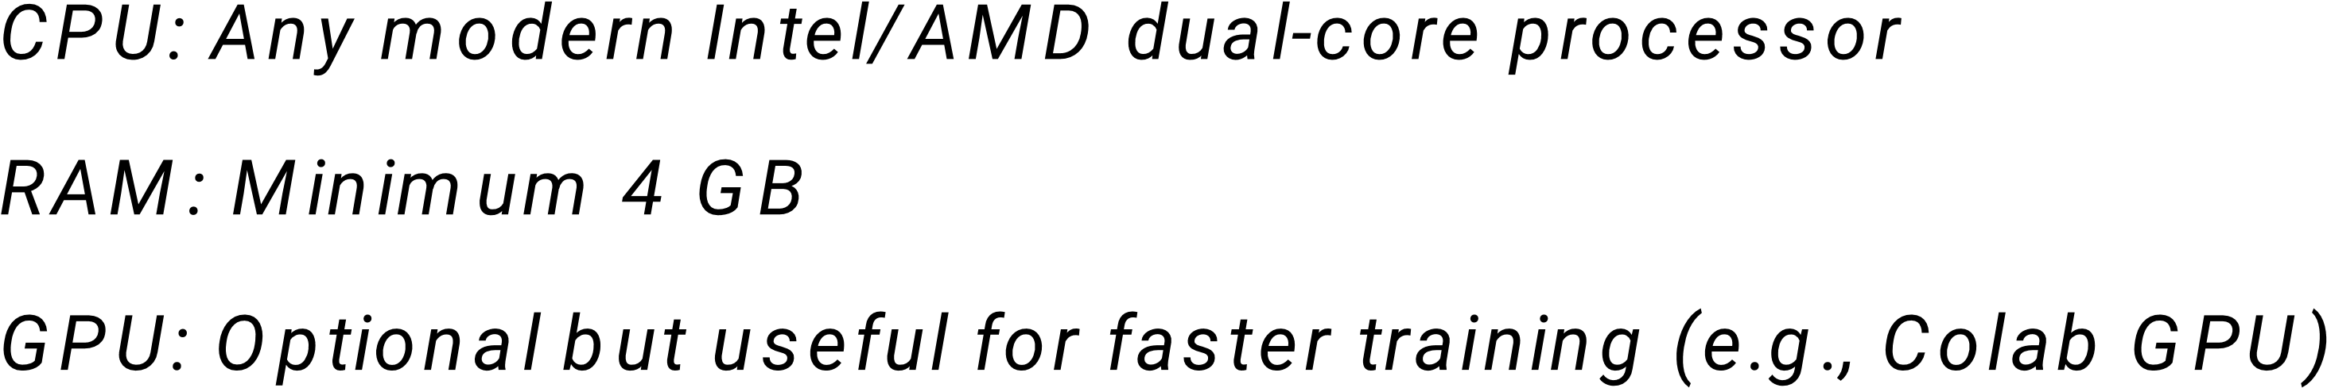V

V

V

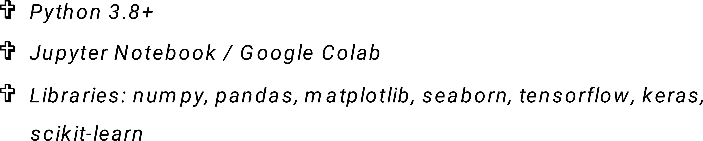

## 4. Objectives

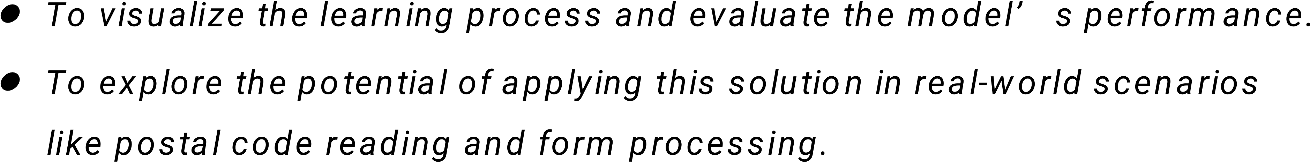

## 5. Flowchart of Project Workflow

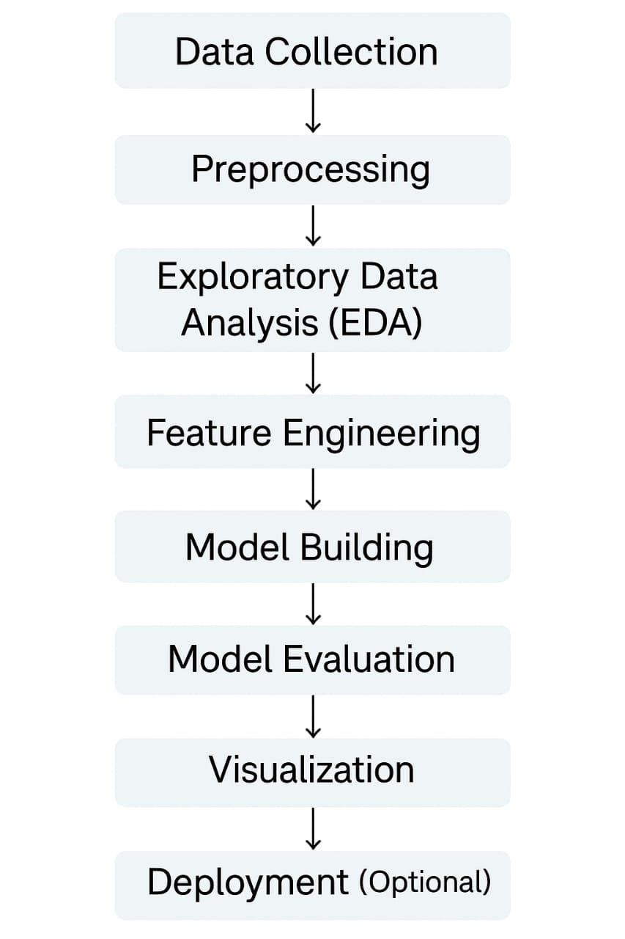

## 6. Dataset Description

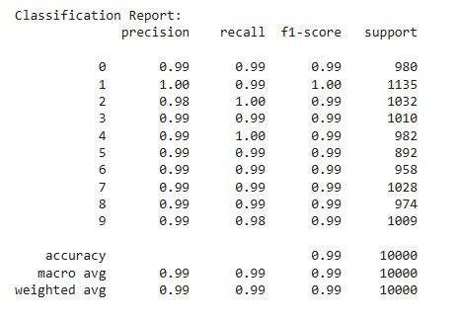

## 7. Data Preprocessing

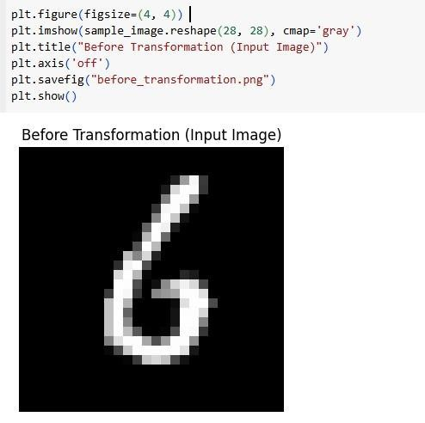

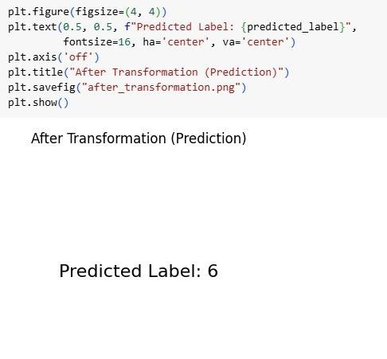

## 8. Exploratory Data Analysis (EDA)

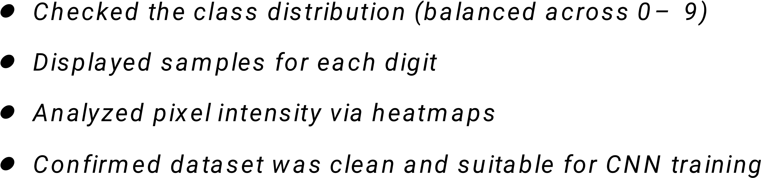

## 9. Feature Engineering

## 10.Model Building

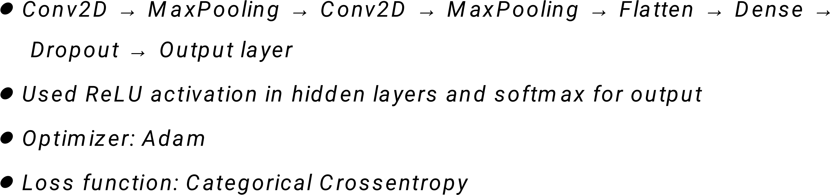

## 11.Model Evaluation

## 12. Deployment

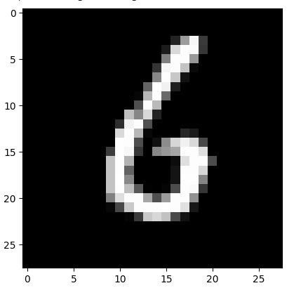

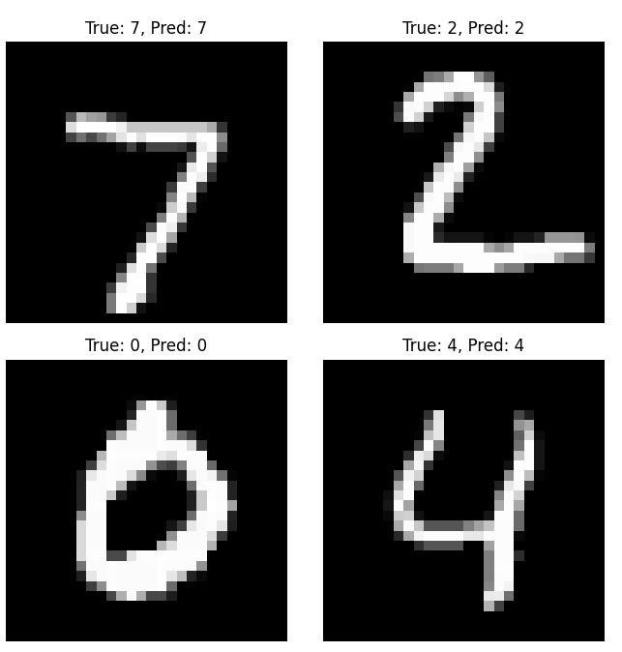

## 13. Source code

## 14. Future scope

• 

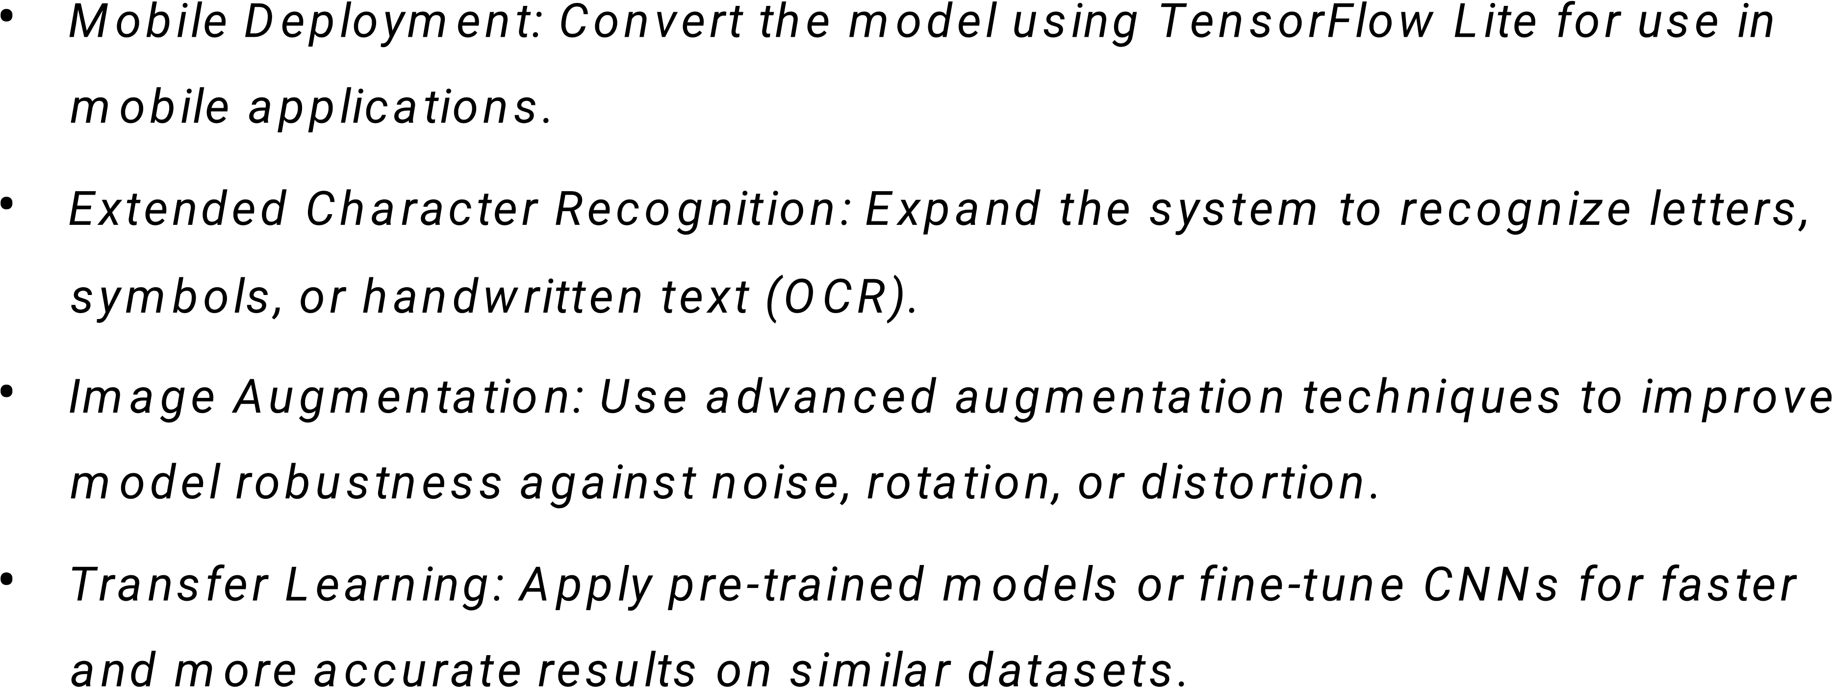

## 15. Team Members and Roles

